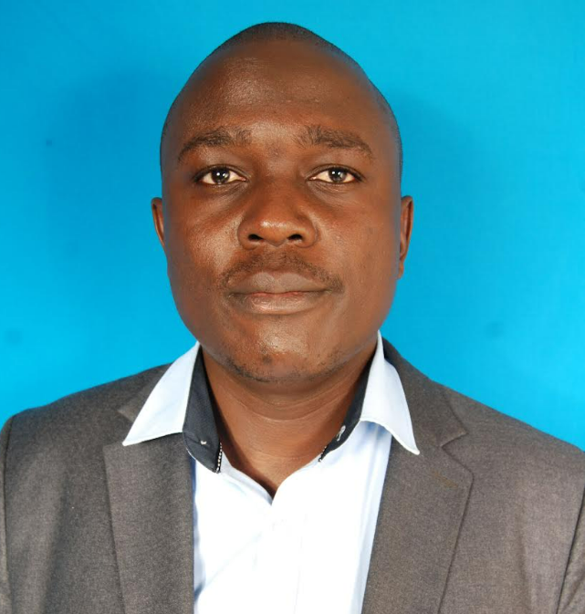

Oliver Ogutu, PMP, ITIL V4.
Oliver is a results-driven Digital Transformation and Project Management Consultant with over 15 years of experience delivering technology transformation, operational improvement, and enterprise infrastructure projects across public sector, NGOs, and enterprise environments.
He has a high level of expertise in project delivery, stakeholder management, business process improvement, governance, service transition and change management.
He is a member of Computer Society of Kenya (CSK), Project Management International (PMI) and also a Member of Kenya Institute of Management (KIM).

